

Q-Learning Management System
User manual

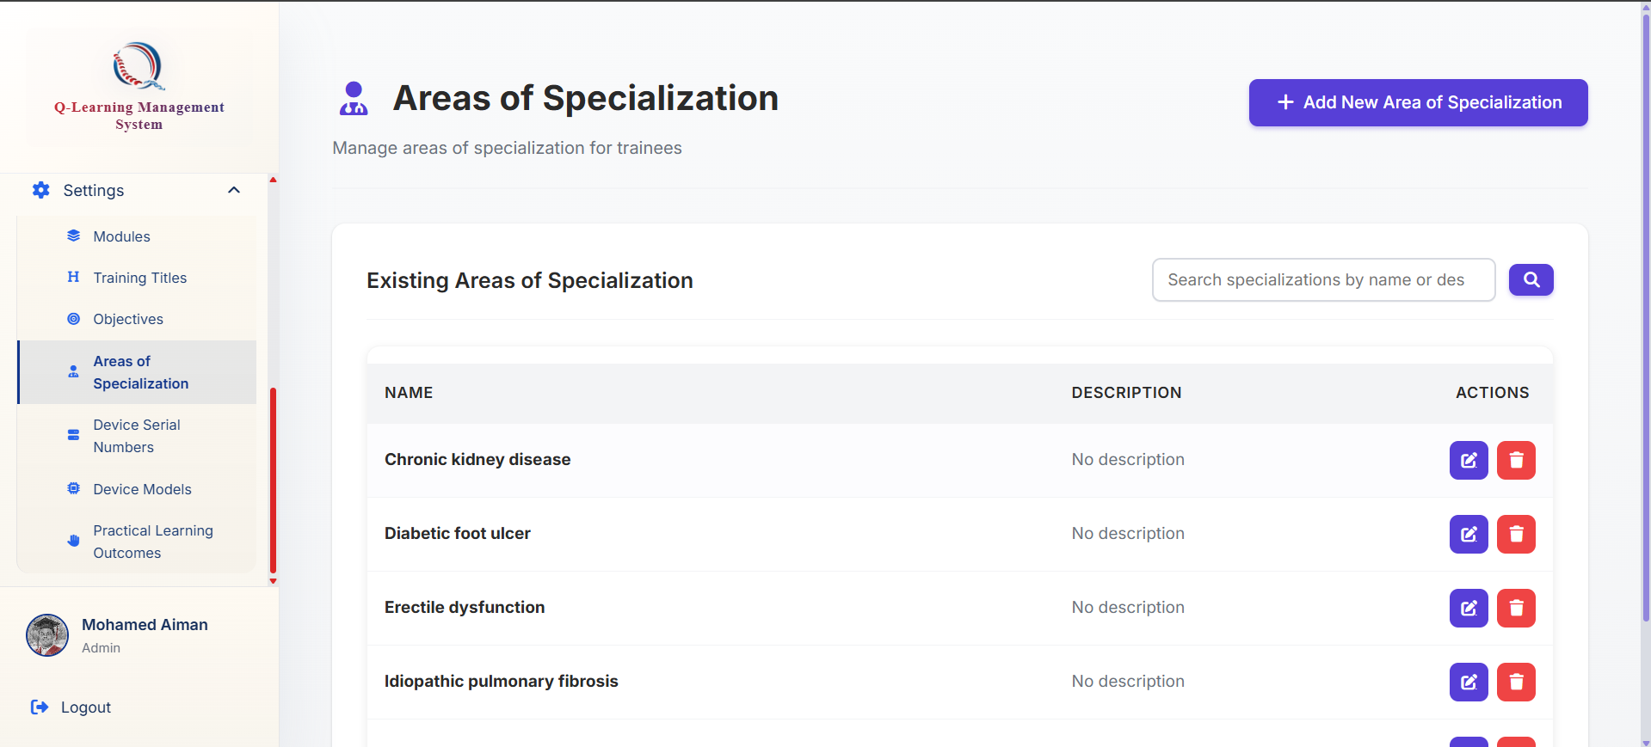
How to add a new Area of Specialization
Click on the add Area of Specialization button
Go ahead to the Area of Specialization tab at the bottom of the sidebar

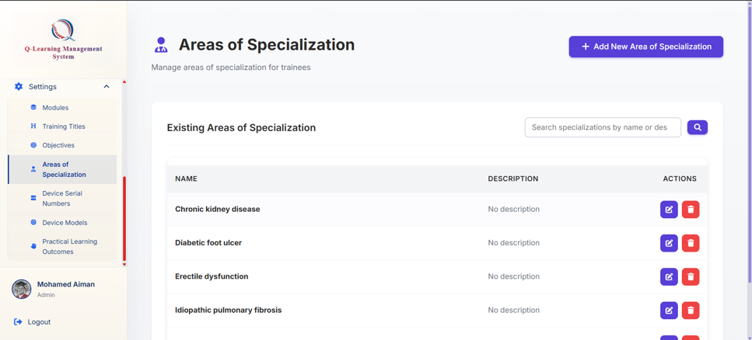

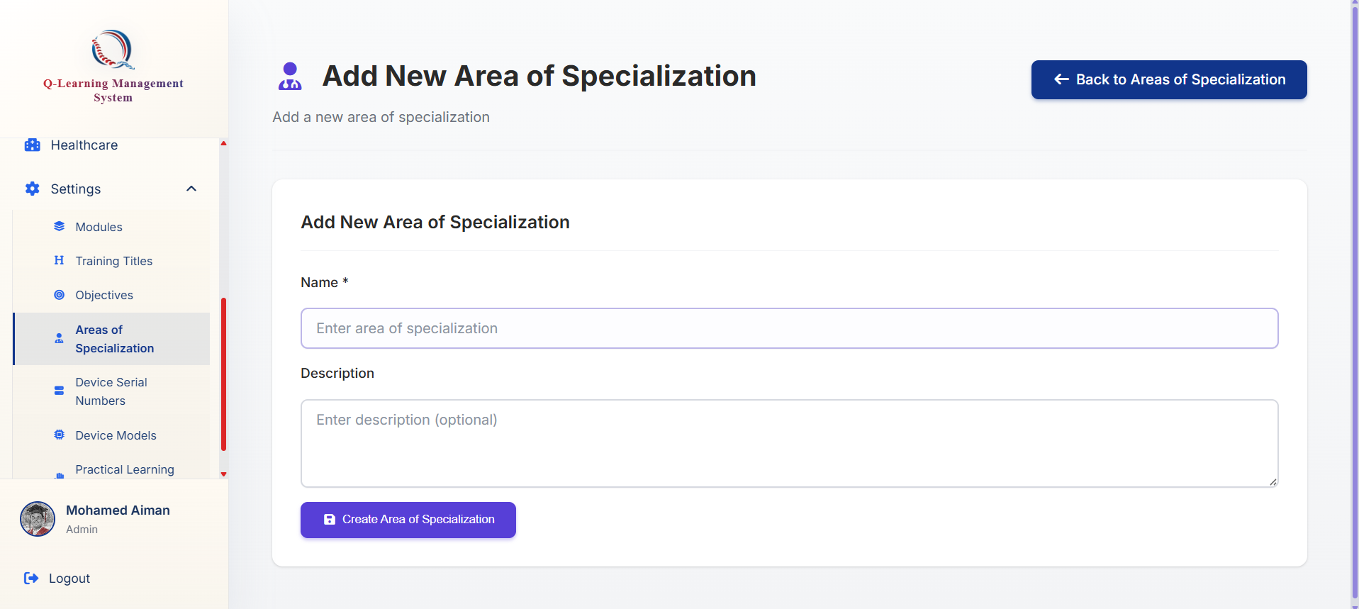
You will be brought to this form where you may fill up the details needed
Click on this button to submit and create

